Hello,

I am hoping you can help with my proposed shed project.

Background.
I am looking at purchasing a modular pre-fab house and wanting to add a 2-car garage, 1 bay hot-house and covered section from the garage to the house and gutters (and eaves if possible) added to the house. I will add a toilet and shower and room for a washing machine and laundry tub at the back of the garages.

2 car garage
I have a ute (with an 8-foot tray) which is about 6m long. The other car is a sedan which is just over 4m long. I need enough room for a laundry/bathroom at the back of one of the bays so will be guided by you as to how wide the structure should be. In terms of length, I will need enough room for shelves at the sides and part of the rear of the structure. What sort of garage doors can you supply? Ideally I would like an electric roller or tilt door so I can open it from the car when the weather is inclement. (I would need to be open it manually when there is no electricity). One ‘person door’ from one bay on the left side of the garage.

Hot house
At the right side of the garage, I want a separate bay to be used as a garden hothouse. I would like perspex (or similar) for the roof and upper sides of 2 sides of the bay. The side adjoining the garage to be solid. I ‘person door’ opening to the garage section and ideally windows on both the front and side of the bay to allow for air flow. This section could have a skillion roof

Covered walkway
On the left side of the garage section I would like to have a covered walkway/outdoor entertaining area adjoining my house. Not sure if this should be skillion or same profile as the 2 car garage section. I would like this joining up to the house to give an all weather entrance to the house from the person door of the garage. The house will be 4.2m wide so the walkway could be about the same width. I am happy to discuss the length of this section and happy to work in with what works with standard sections.

Guttering
The house is the widest that they can supply so I have designed it without eaves and gutting with a view to getting them put on later. (They say that this is possible - so I am hoping this is right!). Therefore I need gutters and, if possible, eaves around the 15mx4.2m pre-fab building, the walkway, the garages and the hothouse section. I will be totally off-grid so need to collect as much water as possible. I need to have the sufficient clips to give the strength in this very cold climate. (My current shed elsewhere on the property has damaged gutters due to clips not being close enough together. I would also like gutter guard to minimise leaves collection in gutters and water tanks and to reduce bushfire risk.

The address is 1190 Gingkin Road, Gingkin. Elevation is 1280m so I will need all sections to have adequate strength and profile for the snow loading requirements of the location.

Do you provide building services or just the materials?

I have added a rough sketch of what I am looking at for your information.

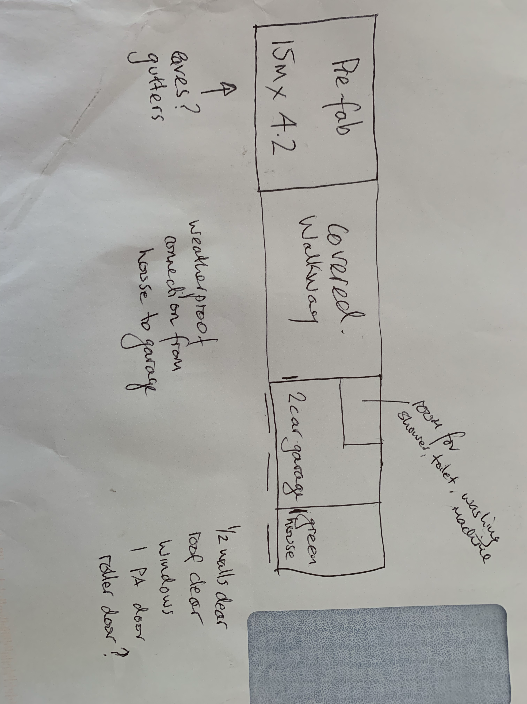

I look forward to discussing my project with you.

