Gherang Shed - December 2024
Shed requirements:
- Main shed to house horse float of 6m long and 3m high. Shed to be approx 9m wide and 8m deep and 3m high at lowest point, approx. 15 deg pitch; 3 sided shed.
- Lean-to of 3.49m wide, 8 m deep, with rear wall and approx. 2/3rds side wall; pitch aprox 5 degrees
- Designed so that eventually doors may be added to the front of main shed (roller or sliding – note minimum height requirements.
- Would like the peak filled in (see final picture)
- Designed so that eventually a second skillion may be added to right hand side of shed
- Prefer no internal poles in main shed, or if necessary, just one at the entrance
- Colours to be finalised

Please provide a quote, and let me know if further information is required.
If you feel I have missed any considerations please advise.
Please advise if you are able to construct (install) the shed and the cost for that. Site is level
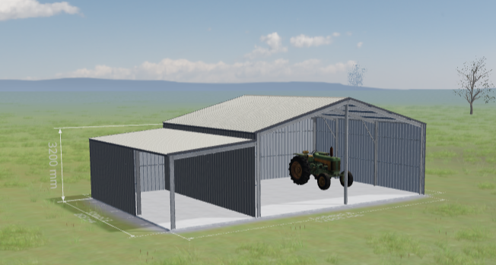
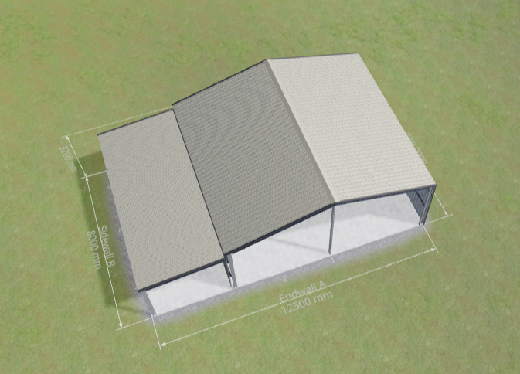
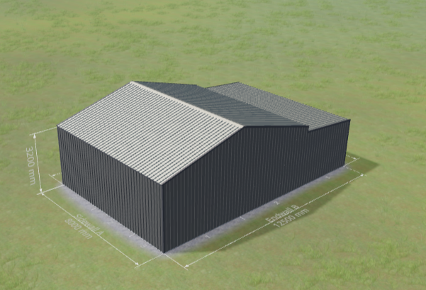
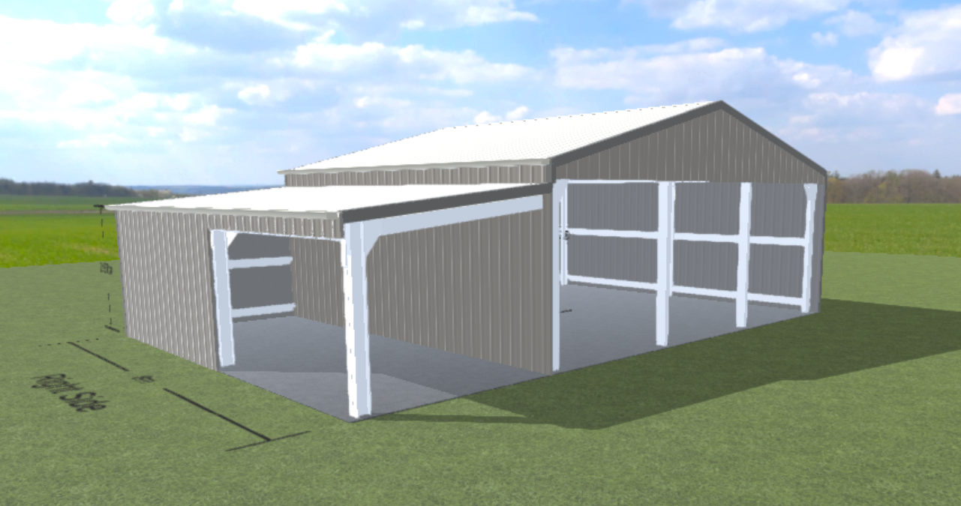

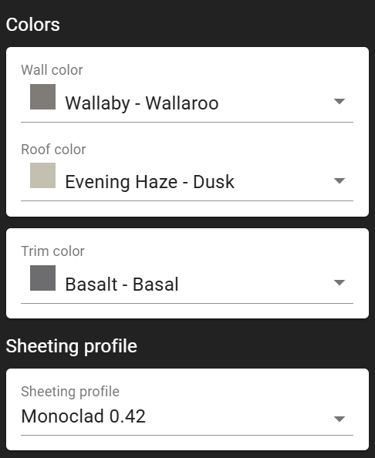
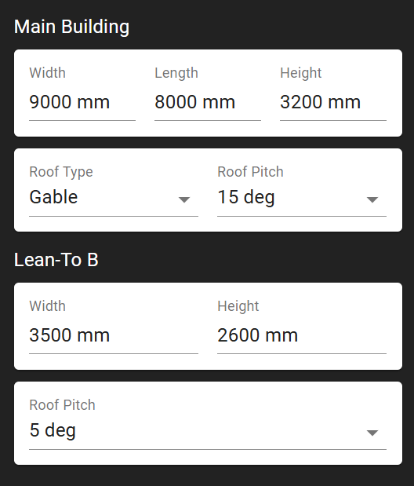

Thank you
Cheryl Nagel
0409 660 977

