Stable quote request
Address: 6 Sullivan Road Gracemere QLD 4702
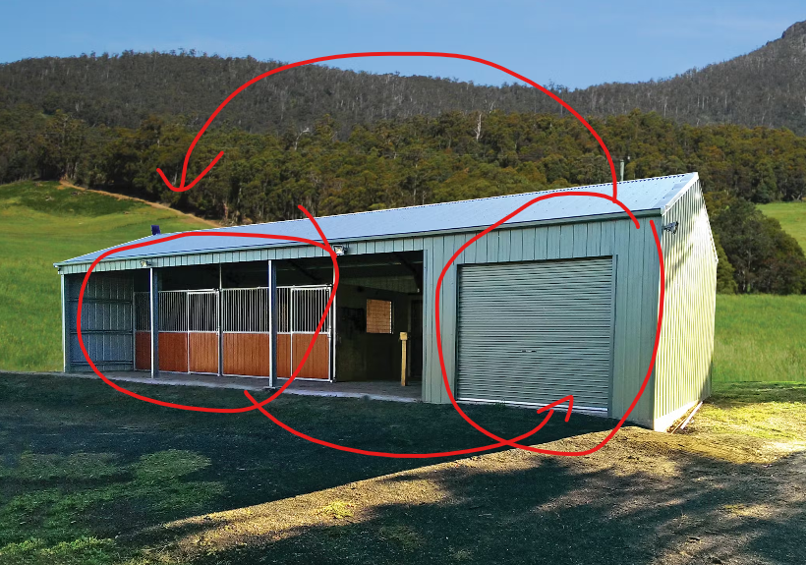

Notes:
- 16m x 6m shed (4 bays)
- Configuration of stable to be opposite to what is shown in pic above (enclosed bay on LHS, open section on RHS.
- Please include option for concrete floor under ONLY the enclosed bay as well as for the whole floor area (if that is typically included in the quotes or please advise if slab is something separate, its fine if its separate).
- Itemise roof ventilation (vent cap) and 3 whirly birds on top
- 1 personal access door to be located on inside front side of enclosed bay - lockable
- Itemise vermin proofing of enclosed bay
- Sheeting profile – whatever is cheapest
- Colour – TBC
- Include roof guttering provision both sides – happy to exclude down pipes for now
- 1 roller door on front of eclosed bay – lockable
- Delivery cost & availability of shed?
- Can you please disclose what is not included – I’m guessing the stalls pictured above are not included? Guessing the quote will be supply only not supply & install?

Sketch notes:
- Sketch is indicative only and subject to change pending additional info
- Red indicates whirly birds
- Blue indicates doors
- Large section to be open fronted

