1 NORTHUMBERLAND STREET
MORPETH, NSW

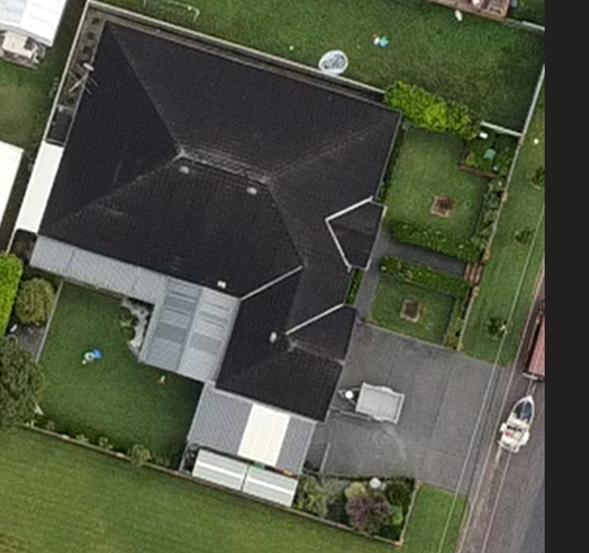
Proposed Patio Type Ext

