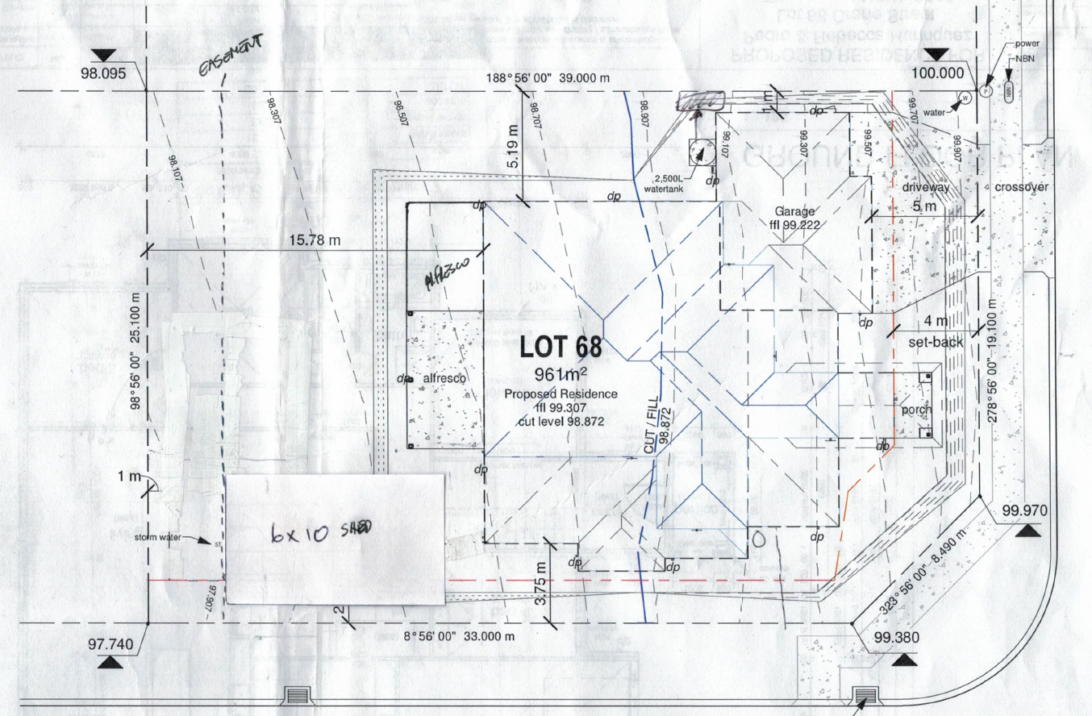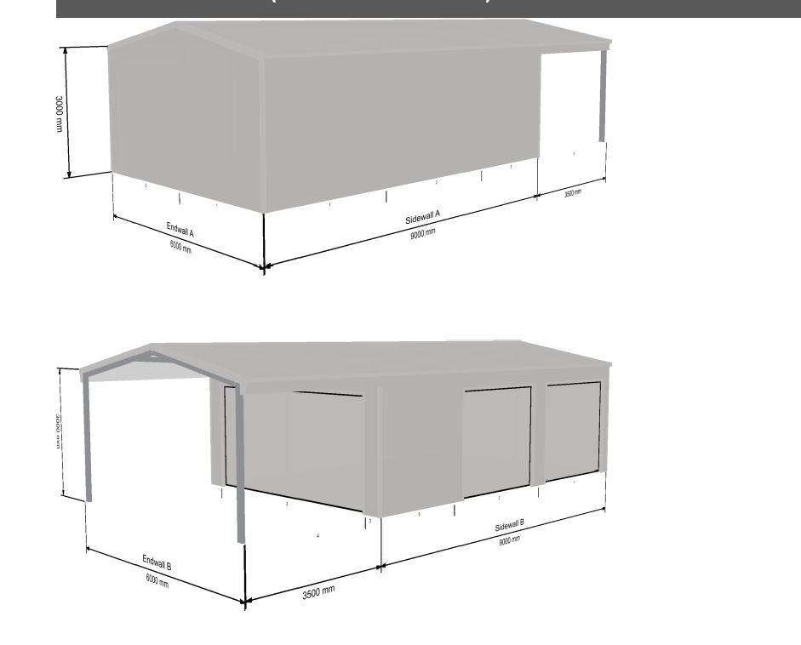
1mtr from fence. 2 single garage doors for access
Pool
Lean 2

End wall A will need a PA door

