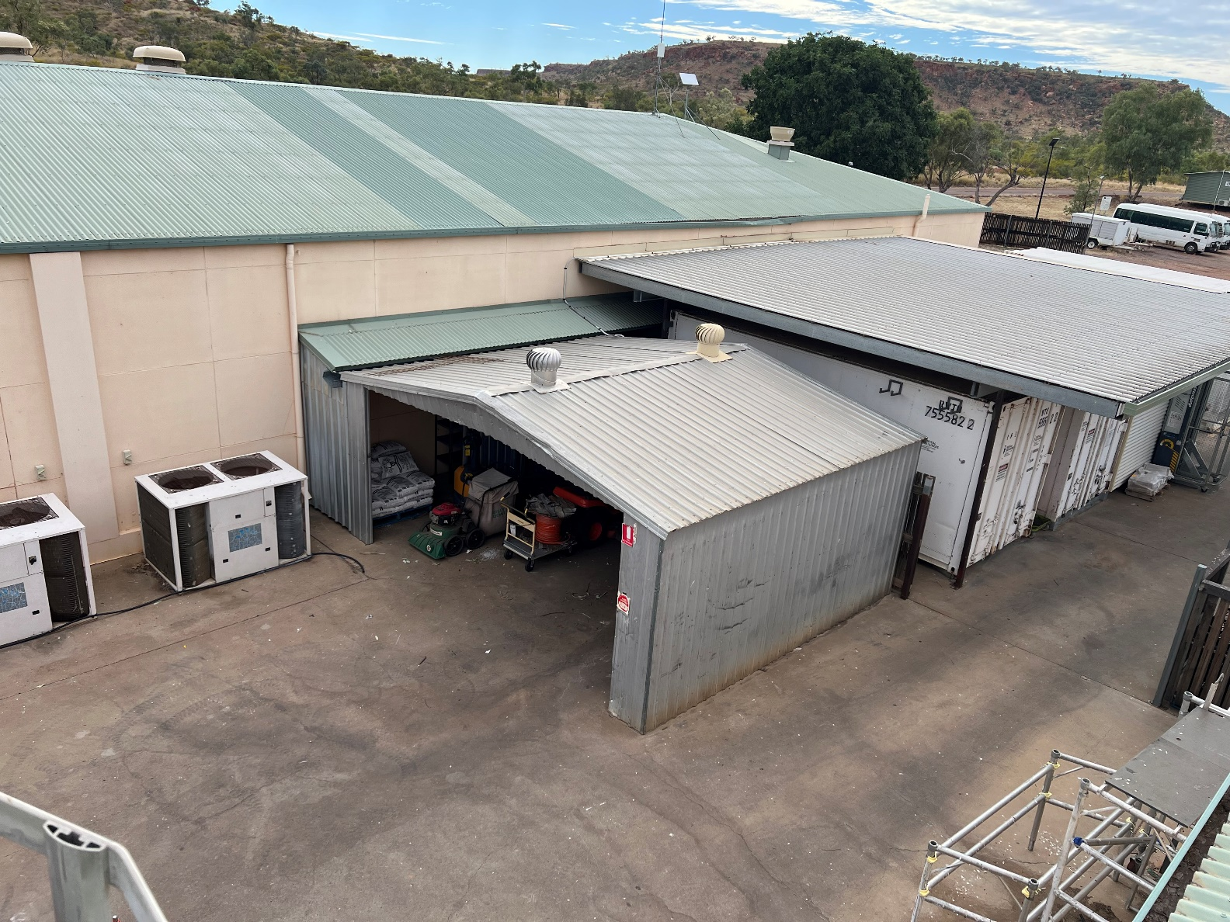
5.4m
6m
2.3m
6m
Shed x 1
Dimension : 6m x 6m
5.4m x 2.3m Open side
Colours: * Refer to the buildings near the shed in the picture
Walls: Cream
Roof: Green
2 x Whirlybird

