Shed Plans
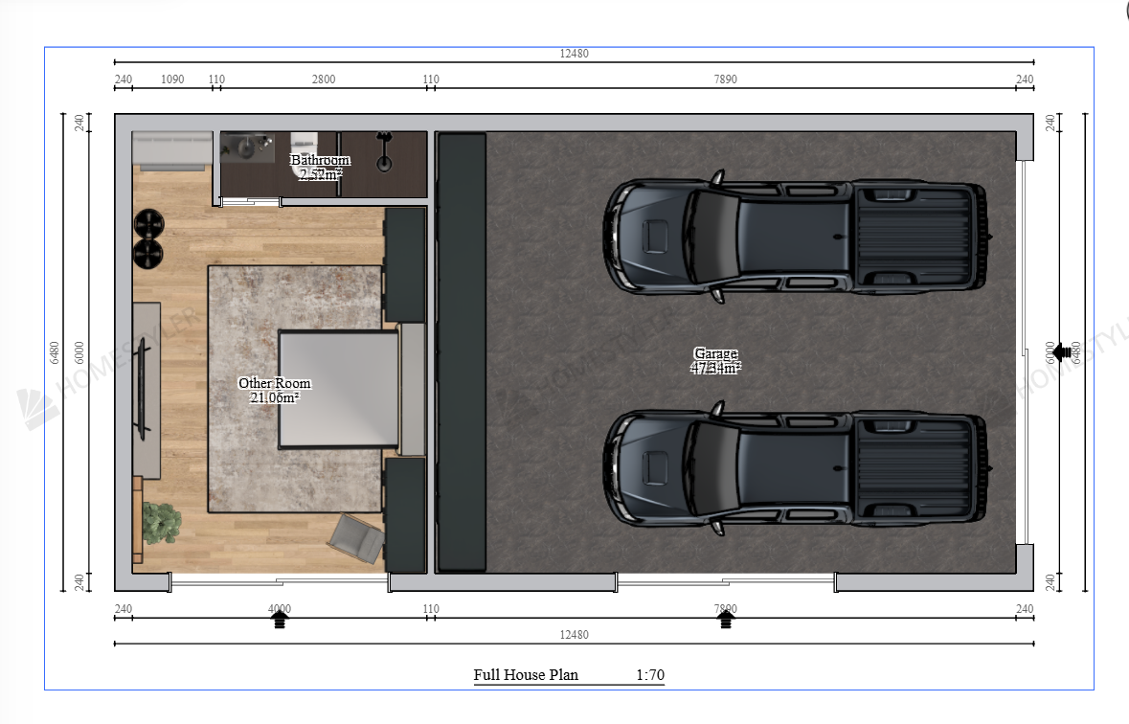
Roughly 6mx 12m area with wall height approx 3m and gable roofline above the 3m line. Garage door height to allow for a caravan, boat or tall vehicle to park. The portion connected to the garage doors to be roughly 6 x 8m, and the section with the studio/living area to be roughly 6 x 4m. Two stacker sliding doors or French doors on one side to allow for pedestrian access to the studio and garage area. Please see attached rough floor plan of space and doors. I addition to this, a small verandah off the side (approx 1m wide) running the whole length of the shed on the side of the stacker doors/ pedestrian access - this is not noted on the floor plan. Gable roofline and Colorbond colours – monument on the roof/ gutters and dover white on the walls/ downpipes.

