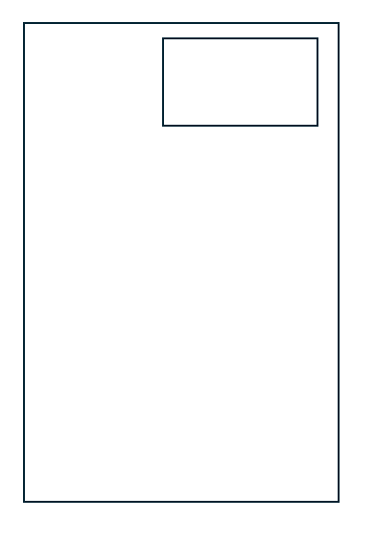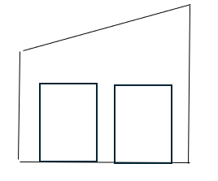
In this option the existing shed/slab would be demolished and new shed + slab installed in SE corner of the block. Putting the new shed the closes to the corner as it can go.
Shed 7m Wide x 9m Long, Skillion Roof to the right, 2x windows in East Wall.

