5000mm
2 x 4000mm bays
6000mm Liveable area
8000mm
Skillion Roof Line 5% - High End at roller door front

3600mm

2500 H x 2700 W
Electric Roller
3500 H x 3000 W
Chain Drive
4000mm

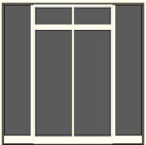

W/C
Shower
Bedroom
4000mm
4000mm
1000mm | 1000mm | 1000mm | 1000mm | 1000mm | 1000mm
Floor Plan of Liveable area of the shed
Washing Machine
I/G Hot water system
Gas Bottle
Gas Burner
Sink
Window
Lounge
Internal door
Windows
Glass Sliding Door
Kitchen
Pedestrian door into roller door section of shed

