Proposed Construction Plan
17 Logistic Avenue
Can you please provide a rough quote the following
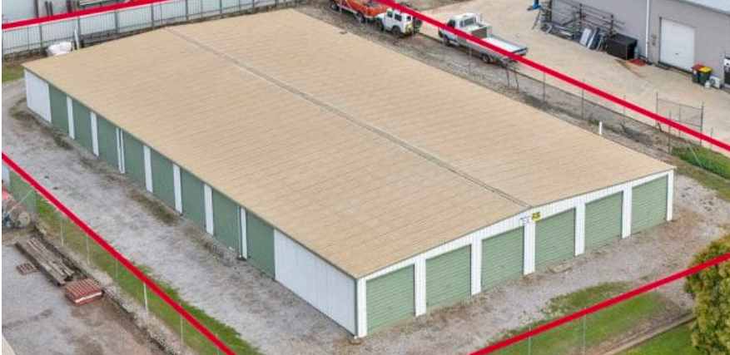
Just have to add two more (3x9 back-to-back) to the end to make 30.
Single toilet only in one build. This will provide enough space for disability provisions.
Shed space = 39m long x 18m wide (need to include structure widths based on 30 units).
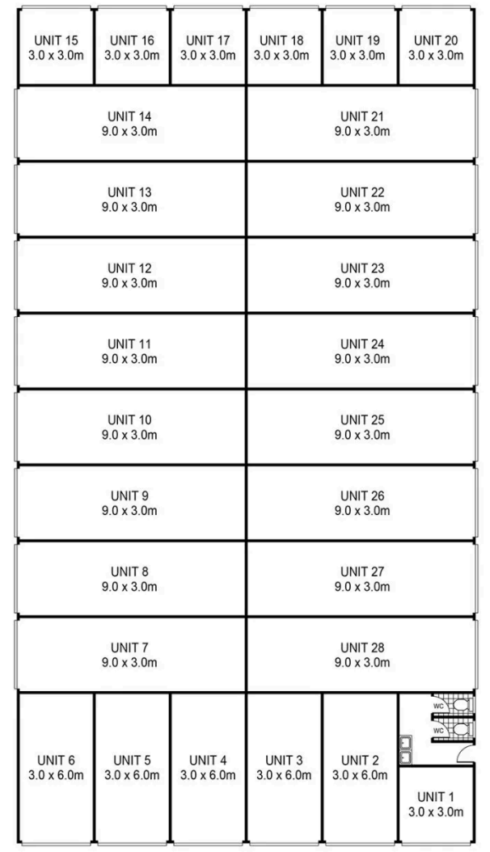

Charles Jones – 299 Whitehouse Lane, Tamworth. 2340. M: 0427315860

