My preferred layout / dimensions as follows.
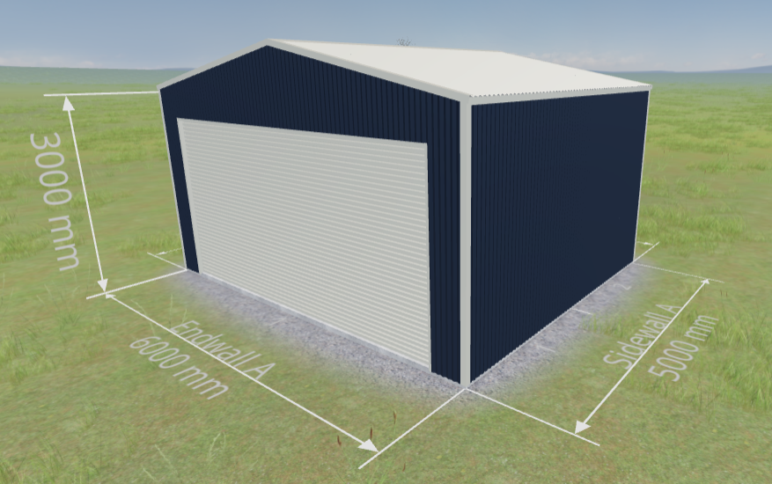
The preferred location of the shed within my backyard is as follows.
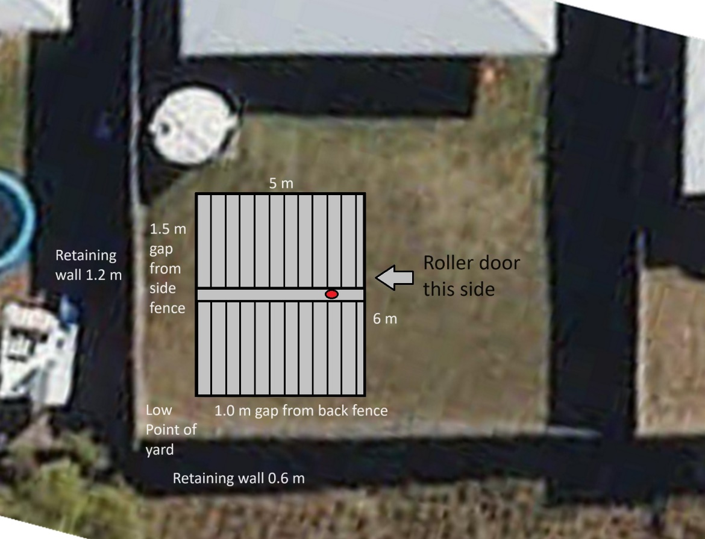
The yard in this location is mostly fill, and the back corner near the proposed shed location is the low point of the yard. Can you advise if this will cause any drainage problems because if this is the case I would rather move the shed.
I want lights in the shed and 2 x dual GPOs.
I am also interested in a mezzanine floor and maybe skylights.
We would like to explore the idea of rigging an aerial hoop from the apex, about 0.75 m from the roller door (the red dot in the attached picture). Can you please advise what load the frame would be able to support in this location, and how this would change if an additional portal frame was placed at this point?

