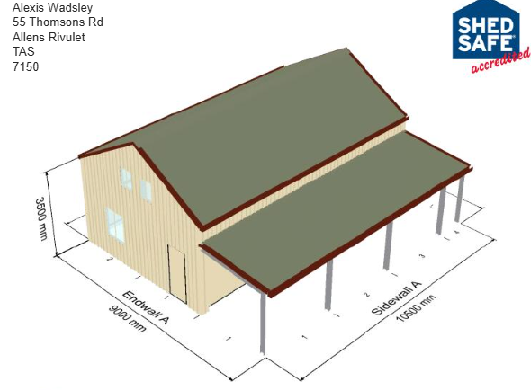

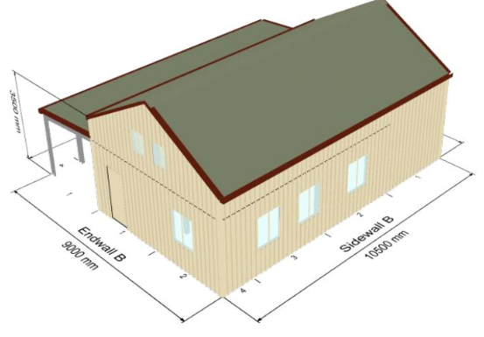

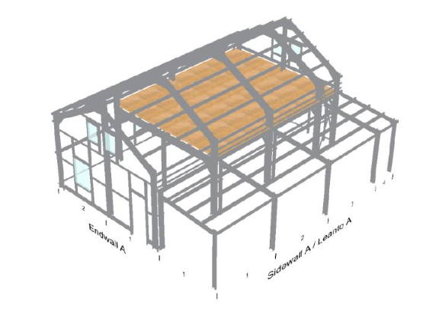
Note Mezzanine here is not quite right, should extend all the way to endwall A (Bay 1) with void at end wall B (Bay 4).

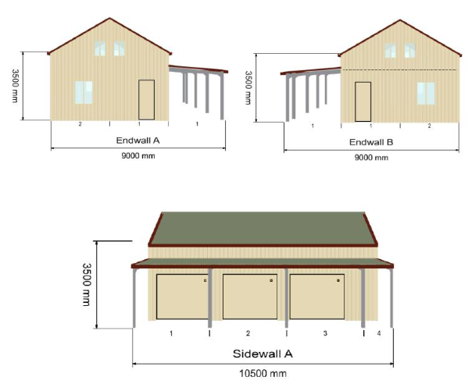
Note door at End wall B should be at Bay 4 in Sidewall A.
Slab for shed, no slab for step out (post footings only)
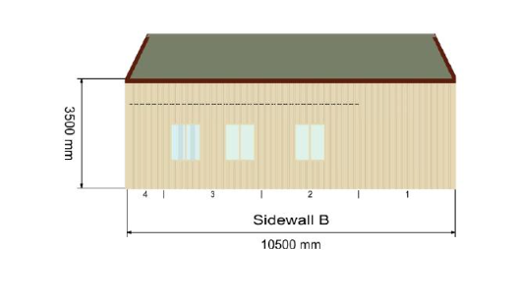Note Windows should ideally be spaced with 1 in the centre of each Bay, 1,2 and 3.

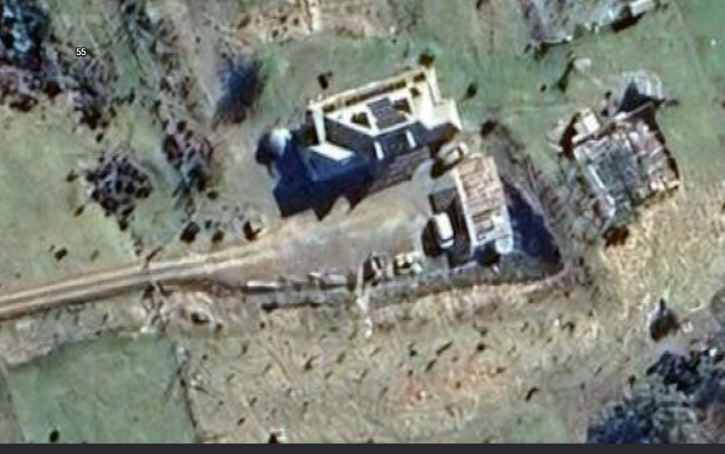
Location on site (55 Thomsons Rd), minor levelling on turning circle, no excavation.
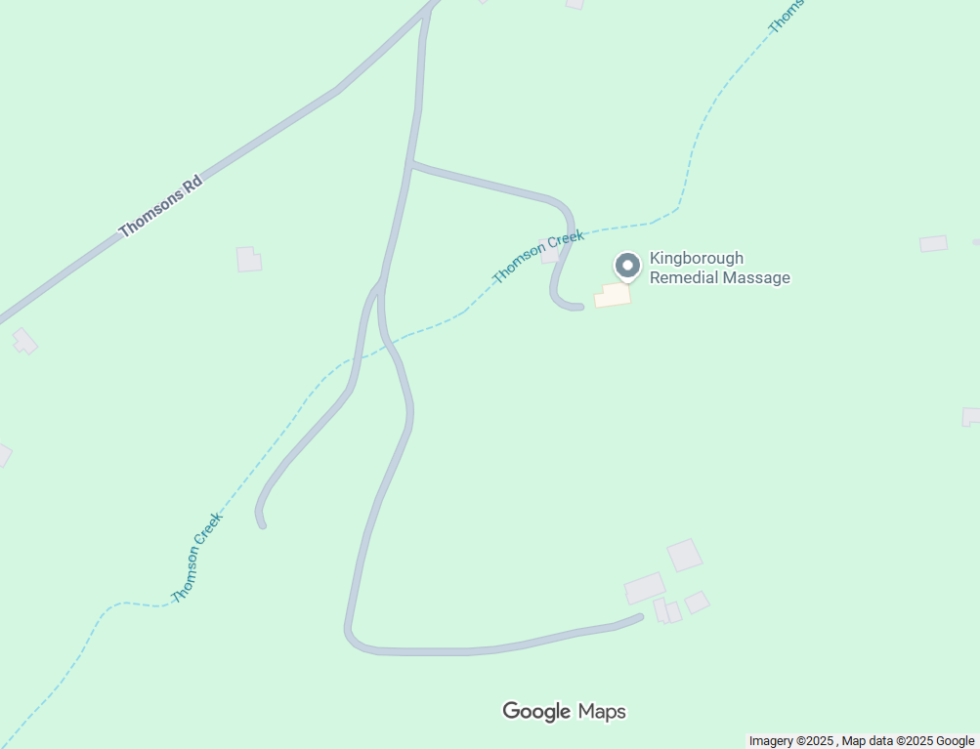
Location on property at 55 Thomsons Rd Allens Rivulet.

