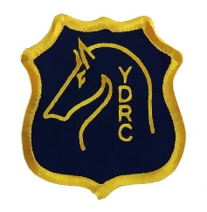 | Yea & District Riding Club  Tiny Towns Fund  Letter of Support  25/02/2024

OVERVIEW
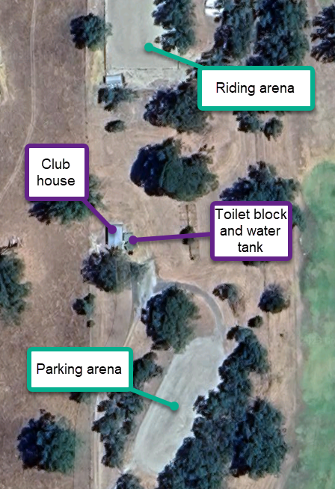
The Yea & District Riding Club has established itself over the last few years as a capable venue for like-minded riders to come together for further education and training in various disciplines. The arena has been a huge success, and the club has been able to maintain it through fundraisers and hosting events.
We now also have a Pony Club, which has been running for over a year, and is also a hugely successful venture for the children of the area. The kids have been doing riding lessons in the one arena, and theory lessons in the existing shed.
We have recently been successful in obtaining 2 grants from council; one for the creation of a cross country course, to help increase the skills and experiences for both kids and adults alike, and the other to fix up the toilet block, which has been termite damaged for years and needed the structural timber replaced and doors added back on.
The last major step for the clubs is to now have a safe and enjoyable club house, that can be used all year round.
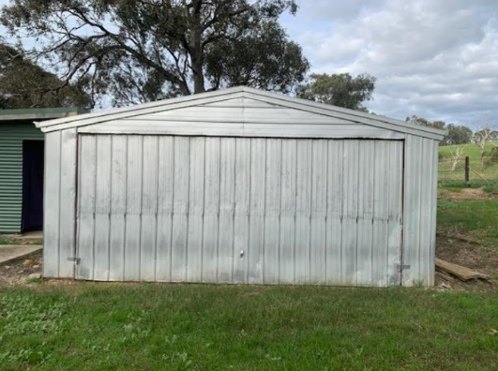
Reasoning
- The current clubhouse is lockable, however it is just a shed on a slab, with a single up-swinging door. There are no windows, lights, PA doors, insulation or plaster walls.
- In summer, the shed door is wide open, however it is also quite hot inside with no ventilation. There is also no power or running water in a sink. There is no shade outside other than under trees, but the ground is not flat here and so putting chairs down is unstable and must move as the sun does.
- In winter, the shed is cold, and the rain/wind sheets straight into the door opening. There is no protection for the items inside near the front.
- There is also a safety aspect that we would like to address. The extensive termite damage in the toilet block has extended to the shed and skirting board, leaving large gaps under the walls. The shed is also not vermin proof, and we need to bait regularily- which is a large conern for the food and club items that are stored there, as well as the small children that attend as part of rally days.

Proposed Upgrades
- Removal of the current shed, and retaining the current concrete slab- presuming that the current slab is in good condition to be kept, under a building permit.
- Installation of a new kit shed, 5m x 7m, with an extended 4m veranda (pics attached) .
- Installation of plumbing, electrical wiring, insulation, plasterboard, cabinetry and kitchenette.

Extra Information
- Attached is an itemised list of works to be done, and the rough costs involved.
- We have plenty of volunteers that are willing to help, so would be happy to have working bees as much as possible to reduce costs.
- Both clubs have a small amount of money that would be going towards the upgrades, as per the grant rules of contribution.

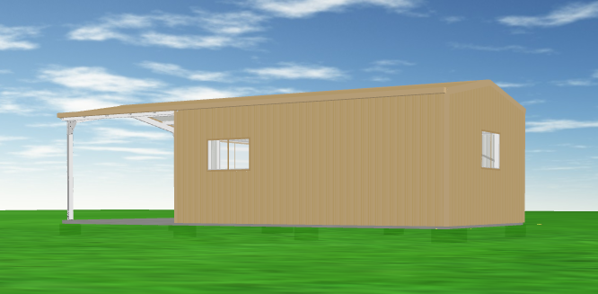
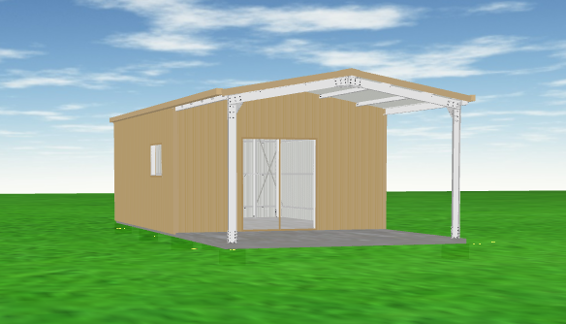
Proposed Shed Diagrams

