
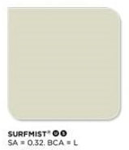
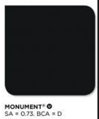
Door opening sizes:
Sliding door 2100mm
Garage PA door 820mm
Bedroom doors 2x 820mm
WIP Cavity door 820mm
Dining Cavity (French) doors 2x 720mm
Toilet Cavity door 720mm
Bathroom Cavity door 820mm
Bedroom 1 Cavity door 720mm
Back Door 820mm

Window sizes:
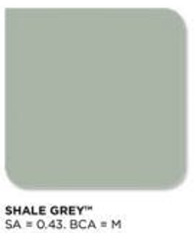
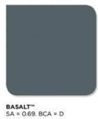
Bedroom windows 2x 2100 x 1800mm
Bathroom window 1200 x 900mm
Toilet window 600 x 900mm
Kitchen 1200 x 1800mm
Living 1200 x 1800mm

Colours:
Roof - Basalt (Corrugated)
Gutters/Trim - Basalt

Downpipes - Shale Grey
Roller doors - Basalt
Garage door - Shale Grey (Horizontal Cladding)
Back door - External Basalt, Internal White
Windows - Basalt
Walls - Shale Grey (Horizontal Cladding)
Garage wall (Vertical Corrugated) under Verandah and x3 Verandah poles - Basalt
Verandah Eaves - Basalt (Corrugated) Parallel to gutter (same direction as deck)
End-fills (bottom house to ground) - Shale Grey (Horizontal Cladding)
Fences / Rainwater tanks - Monument Gravel driveway - Lime stone (Surfmist)

Floor level height from ground - 0.7m (or lower if this height requires guardrails on Deck - I do not want guard rails.)



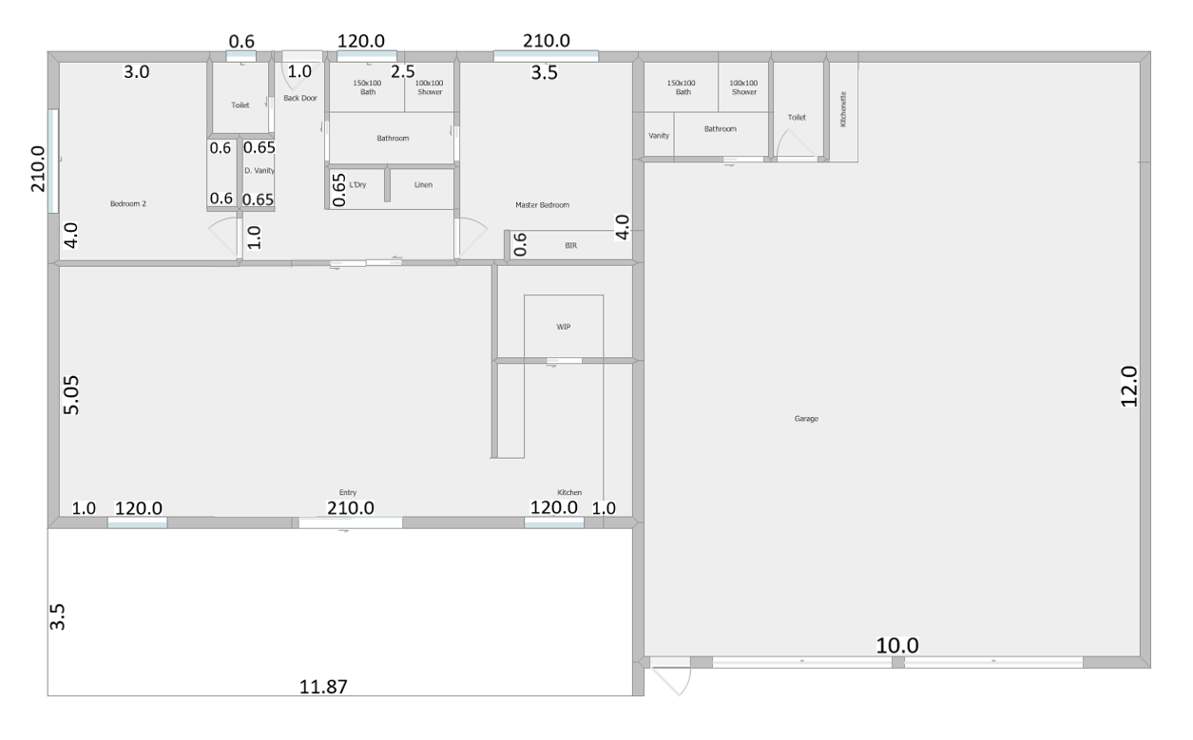
Internal wall room and window sizes: (Walls 110mm)
Plan 1: Garage and home under 1 roof line - Gable as in diagrame.

Plan 2: Garage with Gable over Roller doors and Home with Gable over side walls with Verandah across front (or verandah under main roof).

