Hello I have been trying to sort out which way to go with my shed build.
sorry for the changes.
Lot 100 Stanfield rd Coulson QLD 4310 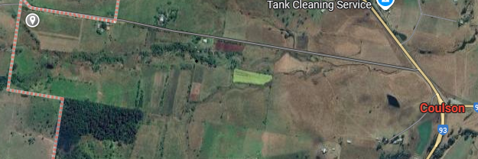

I am looking at Gable roof ,
itemised quote for supply kit &, supply and erect
12 meters wide
24 meters long
3.8 meters wall height
5 bay 3 centre enclosed bay either end open gara port
3 roller doors
1 /"A" end roller centred and as high as possible yes chain operation.
2 / centre side just the large standard roller door.
3/ centre opposite end "A" large standard roller.
PA / door as pictured "A" end
3 Windows 1 as pictured 2 long side either side roller

Roof Zinc corrugated.
Walls Wallaby Grey

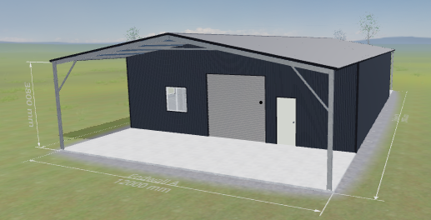A End
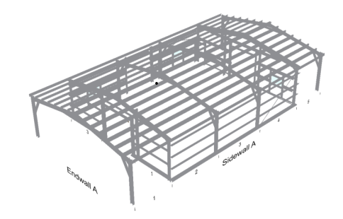
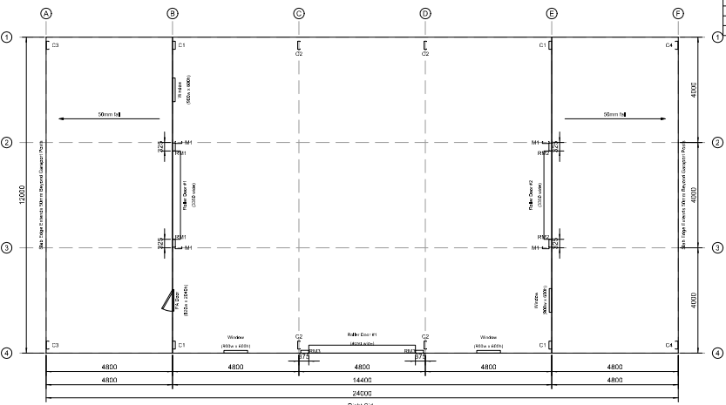
--
regards
Tom Garvin

tomgarvin@gmail.com

