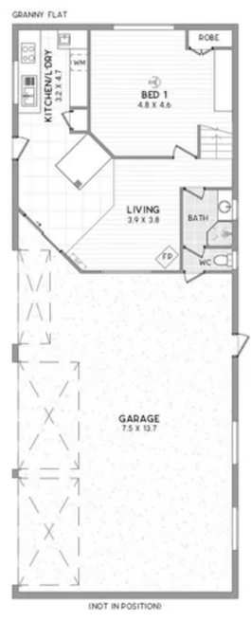
Water Tank and Tylex System
Above unit Mezzanine floor staircase from shed up

