- Dimensions
  - Floor: 6m wide * 8m deep
  - Height: 2.5 to eaves
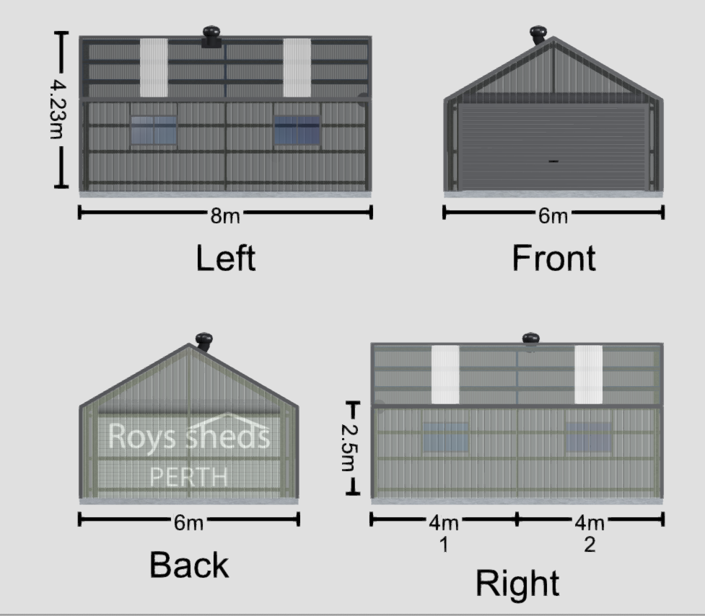
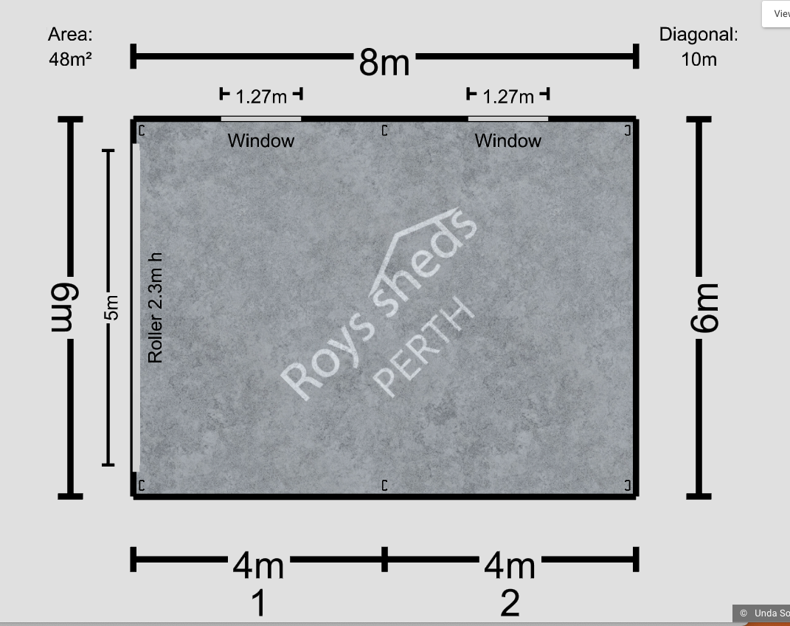
- Materials
  - Roof - corrugated 0.42BMT
  - Walls - trimdeck 0.42BMT
- Colours
  - Roof – monument
  - Walls – monument
  - Doors basalt
  - Flashings – basalt
- Extras
  - Skylights x4
  - Whirlybird x1
  - Windows x2 on left side
  - Roller door motor
  - Roller door – 5m wide x 2.2m high
- Construction
  - If you could recommend any builders you work with
  - We’re located in Killara 2071 NSW

