CUSTOMER DETAILS
Customer Name: ^CUSTOMER^ | Phone: ^PHONE^ | Mobile: ^MOBILENUMBER^
Site Address: ^STREET^ ^TOWN^ ^PCODE^ | Work Phone: ^WORKPHONE^ | Email: ^EMAIL^
QUOTE NUMBER
^CUSTCODE^
Quote Valid for 30 Days
^DATE^

Dear ^CUSTOMER^,
Thank you for your enquiry. We are pleased to present our quote for your new Fair Dinkum Build.
We’re one of Australia’s biggest and most trusted names in sheds and patios.
We believe some of life’s best moments start in our garages, sheds and barns. We’re talking moments like completing that amazing car restoration, hosting a wonderful surprise party – and hearing all Dad’s classic jokes in just fifteen minutes while you prep the boat for a perfect day out on the water.
Great memories like these are keepers. This is why we design and manufacture our builds for a long happy life here in one of the world’s most unforgiving climates. We’ve been supplying quality builds for over 30 years to over 250,000 happy customers nationwide.
<Franchisee to add local spiel here e.g. years of service, previous business name (if that’s important), etc.>
BUILDING SUMMARY |  |  | DESIGN FACTORS
Dimensions:
Span | ^WIDTHm^ |  | Importance Level | ^IMPORTANCE^
Length | ^LENGTHm^ |  | Wind Region | ^REGION^
Bay Width | ^BAYWIDTHm^ x ^BAYS^ bay(s) at ^ENDBAYWIDTHm^ each |  | Terrain Category | ^TERRAINCAT^
Height to the lowest eave | ^HEIGHTm^ |  | Topography | ^TOPOGRAPHY^
Roof Pitch | ^ROOFPITCH^ ^ROOFSTYLE^ |  | Shielding Factor | ^SHIELDING^
Left Lean-to | ^LTLDETAILS^ |  | Internal Pressure Co-efficient | ^CPI^
Right Lean-to | ^LTRDETAILS^ |  | Site wind speed in m/s | ^SITEWINDSPEED^
 |  | Ex GST | Inc GST
 | Kit Only Price | ^PREGSTAMT^ | ^PRICE^
 | Excavation Price
 | Concrete Price
 | Installation Price
 | TOTAL PRICE

Insert Signature
Insert Name
Insert Job Title






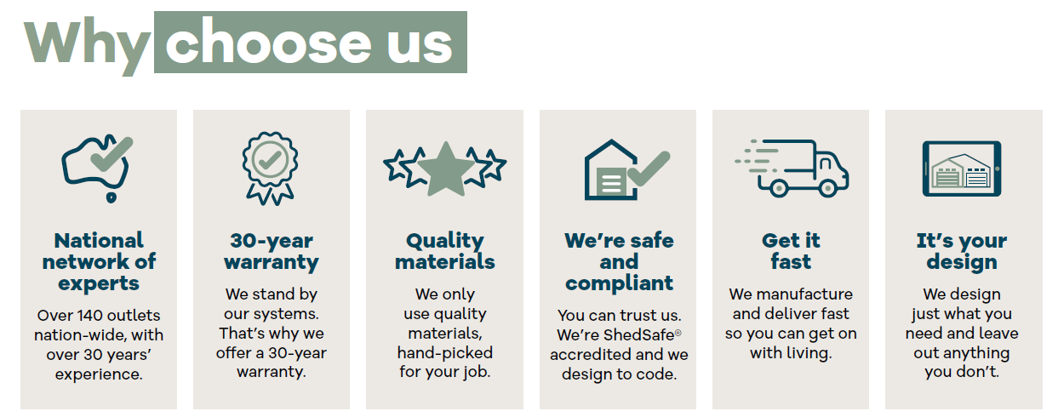
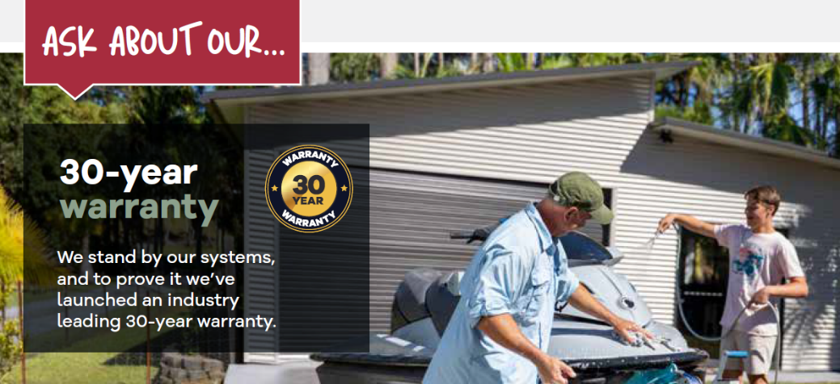
We proudly partner with some of the biggest names in the industry:

YOUR DESIGN
^LAYOUTIMAGE_ROTATE^
YOUR SITE SPECIFIC WIND SPEED ASSESSMENT
For your peace of mind, we are ShedSafe accredited and utilise the Australian Steel Institute’s site check software to ensure your shed design is engineered specifically for your site and local conditions. By using this very accurate and sophisticated program, we can determine your site-specific wind speed to provide you the best solution for your project.
SITE LOCATION
Property Address | ^STREET^ ^TOWN^ ^PCODE^
Job Number | ^REFERENCE^
Building dimensions | ^WIDTHm^ x ^LENGTHm^ x ^HEIGHTm^
Roof style | ^ROOFPITCH^ ^ROOFSTYLE^
Wind criteria | ^REGION^ : ^TERRAINCAT^ : Shielding ^SHIELDING^ : Topo ^TOPOGRAPHY^ : ^SNOWALPINE^

The calculated site wind speed using AS1170.2 is ^SITEWINDSPEED^ m/s for the above property address.
^SITEIMAGE^

BUILDING DETAILS
Walls | ^WALLCOLOUR^ ^WALLMATERIALTECH^
Roof | ^ROOFCOLOUR^ ^ROOFMATERIALTECH^ ^ROOFPITCH^
Gutter | ^GUTTERCOLOUR^ ^GUTTER^
Downpipe | ^DOWNPIPECOLOUR^
Barge | ^BARGECOLOUR^
Corner Flashings | ^CORNERCOLOUR^
Door Flashings | ^OPENINGFLASHCOLOUR^
Roller Door | ^DOORCOLOUR^
PA Door | ^PADOORCOLOUR^
Commercial Sliding Door | ^SLIDINGDOORCOLOUR^
Glass Sliding Door | ^WINDOWCOLOUR^
Windows | ^WINDOWCOLOUR^
OPTIONAL EXTRAS
Skylights | ^SKYLIGHTS^
Roller Doors | ^ROLLERDOORSIZES^
Roller Door motors | ^RODOORMOTORDESC^
PA Doors | ^PADOOR^
Commercial Sliding Door | ^SLIDINGDOORS^
Glass sliding door | ^GLASSDOORSIZES^
Windows | ^WINDOW^
Insulation | ^LININGSCOMBINED^
Open Bays | ^OPENBAYS^
Whirlybirds | ^WHIRLYBIRDS^
Mezzanine | ^MEZZANINE^
Mezzanine Stairs | ^MEZZANINESTAIRS^
Divider Walls | ^PARTITIONS^
MATERIAL SPECIFICATION
Columns | ^COLUMN^ | Purlins | ^PURLIN^
Rafters | ^RAFTER^ | Side Girts | ^SIDEGIRT^
Knee/Apex Brace | ^KNEEAPEX^ | End Girts | ^ENDGIRT^
Left Lean-to Column | ^LLCOLUMN^ | Right Lean-to Column | ^RLCOLUMN^
Left Lean-to Rafter | ^LLRAFTER^ | Right Lean-to Rafter | ^RLRAFTER^
Mezzanine Bearer | ^MEZZBEARER^ | Mezzanine Joists | ^MEZZJOISTS^
Knee/Apex Brace | ^COLUMN^ | Purlins | ^PURLIN^

FOOTING
^FOOTINGTYPE^
^FOOTINGDESCR^
NOTES
^NOTES^

TERMS & CONDITIONS


THE NEXT STEP
Payment Schedule
The following deposit and payment schedule will be required.
 | % due | Amount |  | Due Date
Deposit
On Delivery
On Completion
Confirmation of Order |  |  |  |  |  |  | Bank Details
I hereby agree to place this order based on the details and terms and conditions provided |  |  |  |  |  |  | BSB
Customer name |  |  |  |  |  |  | Account Number
Customer signature |  |  |  |  |  |  | Account Name
Date


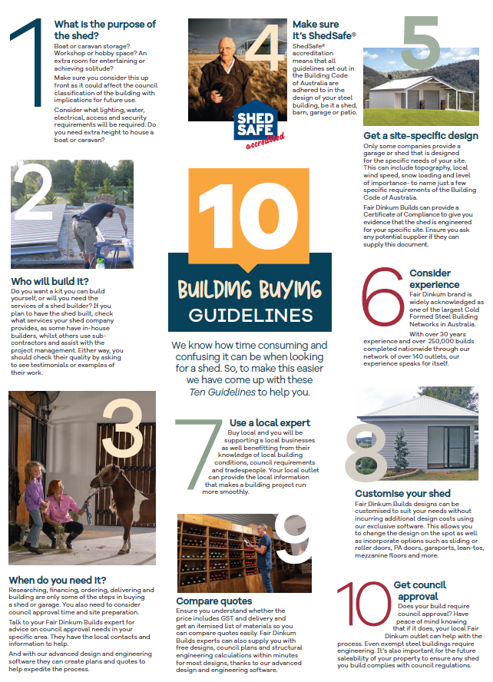

^3DIMAGES_SMALL^

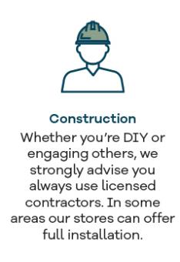

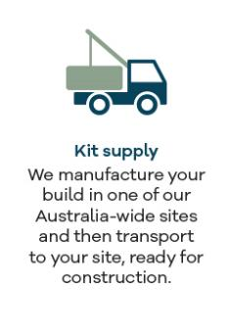
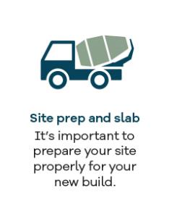
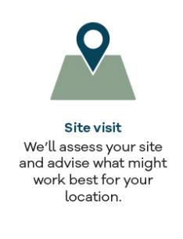
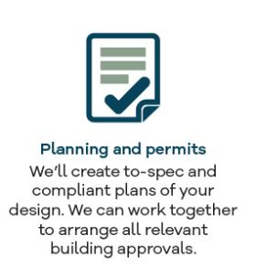
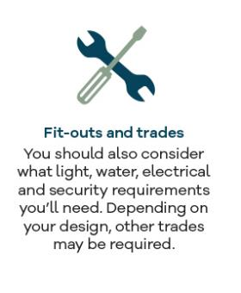

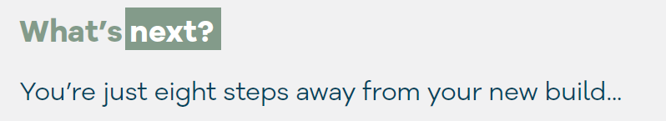
Get started today!

EXCAVATION ESTIMATE
The excavation costs for <DISTRIBUTOR> Quote Number: ^CUSTCODE^ |  | <$PRICE>
Excavation requirements
The excavation team’s estimate assumes the following: | Extra charges may apply for the following:
FOUNDATION ESTIMATE
The foundations cost for <DISTRIBUTOR> Quote Number: ^CUSTCODE^ |  | <$PRICE>
Foundation requirements
The concreting team’s estimate assumes the following: | Extra charges may apply for the following:
CONSTRUCTION ESTIMATE
The construction costs for <DISTRIBUTOR> Quote Number: ^CUSTCODE^ |  | <$PRICE>
Construction requirements
The construction team’s estimate assumes the following: | Extra charges may apply for the following:

