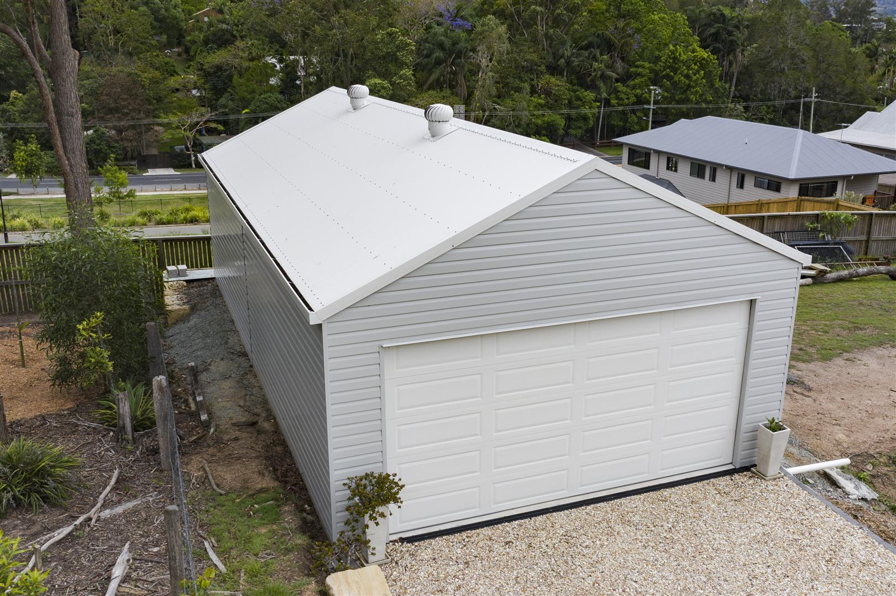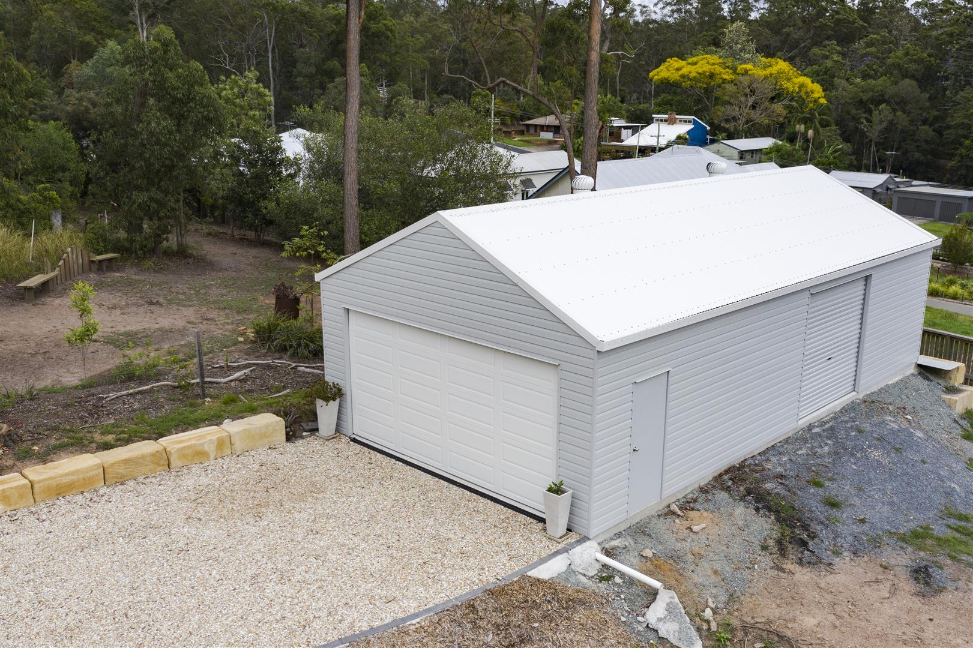
6.050 x 6.050 – 2.7m walls, 10-15 pitch
1 personal door and window + insulation
Double roller – 2320 x 4800 (panelled)

