Awning plan for rooftop

This picture shows where we want the awning to be installed. It would be attached to the brick wall along the 5m length with posts bolted to the concrete slab.
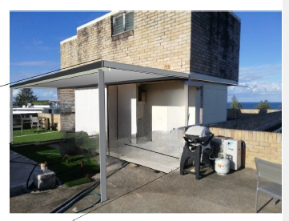

This is the dimensions of the awning 5m x 2m x 2.7m.
Note the engineer has called for C2/50W wind rating

