Ricky Hegarty 0439 670 149 Sandy Hegarty 0422 112 295 sandy.hegarty@gmail.com
Seeking Quote for:
Patio Extension – 2m x 8m X 3m
Garage Extension – 5.8m x 6m x 2.9m with one 5m (?) auto roller door and a door on the back left side

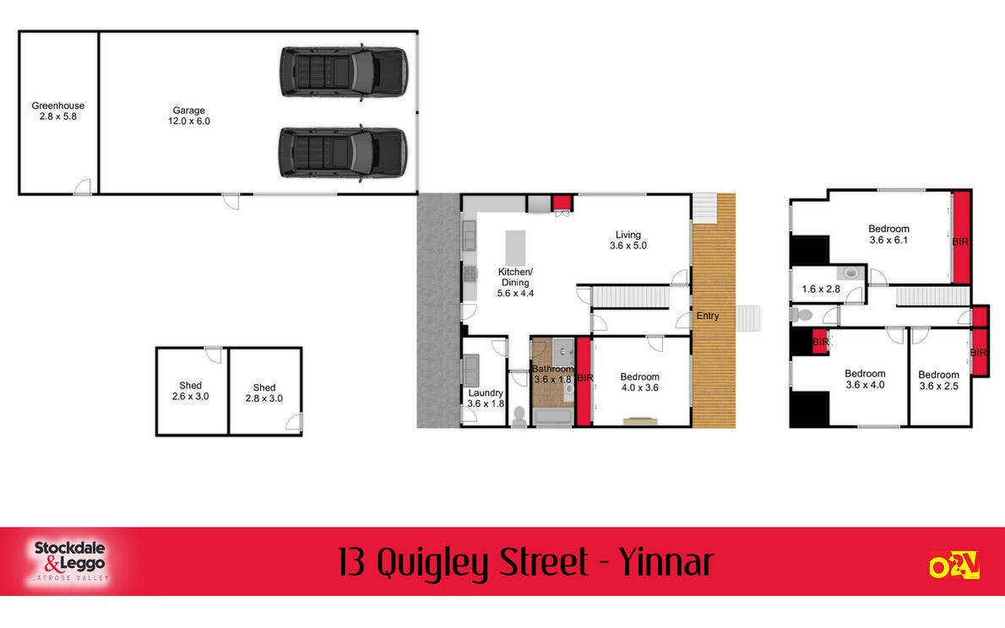
https://www.realestate.com.au/property-house-vic-yinnar-142229704
Garage Extension
5.8 x 6 x 2.9

Patio Extension
2 x 8 x 3

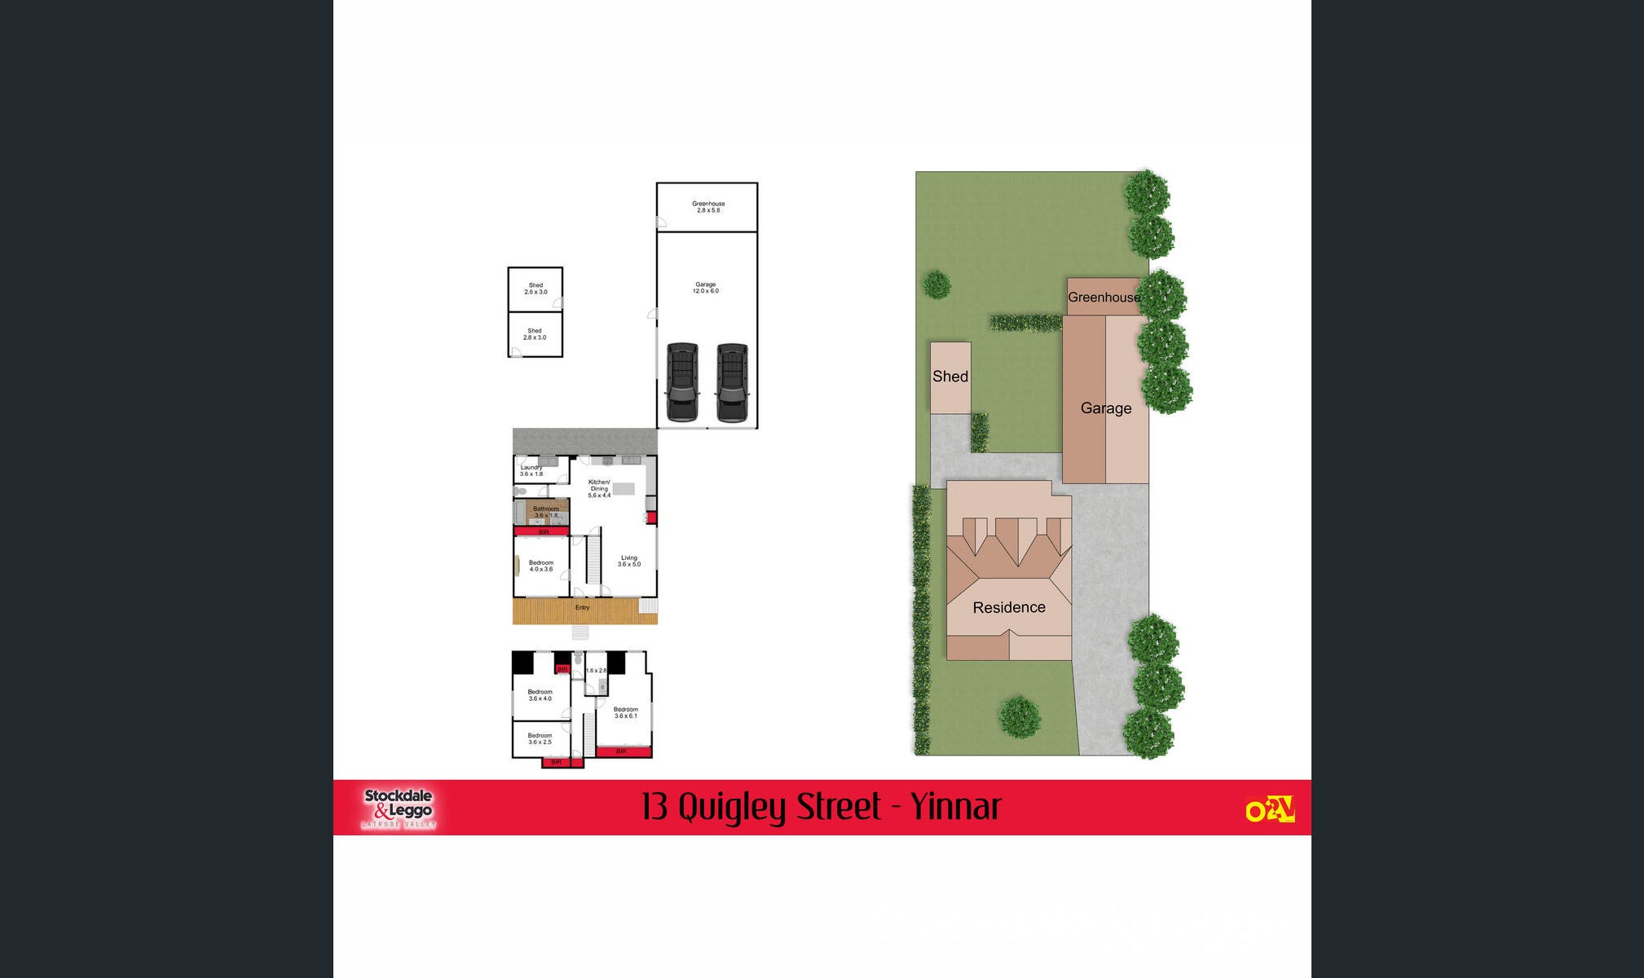

Patio Extension – 2m x 8m x 3m
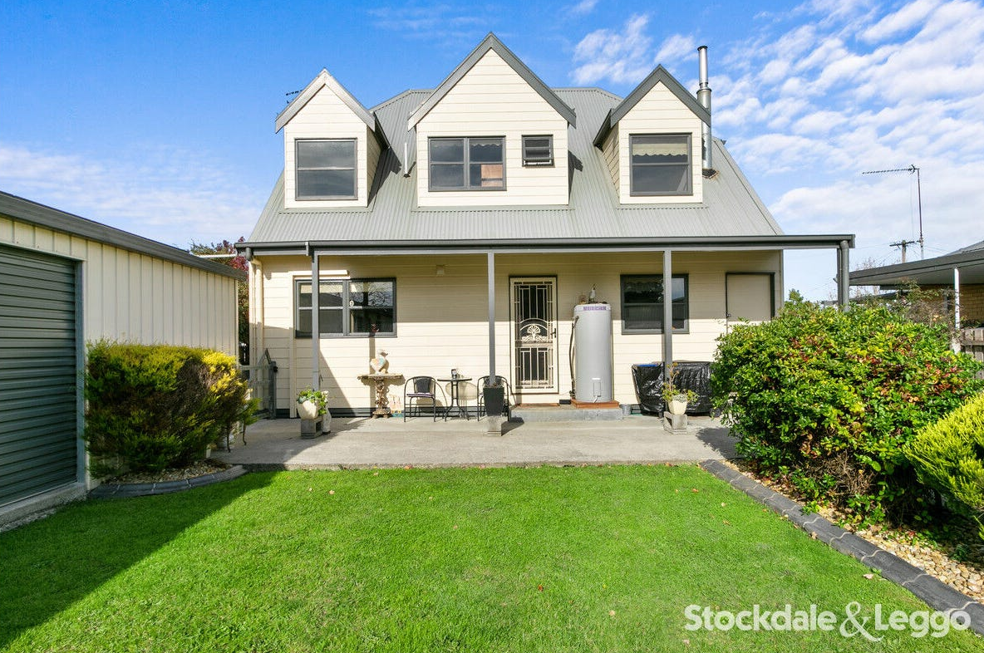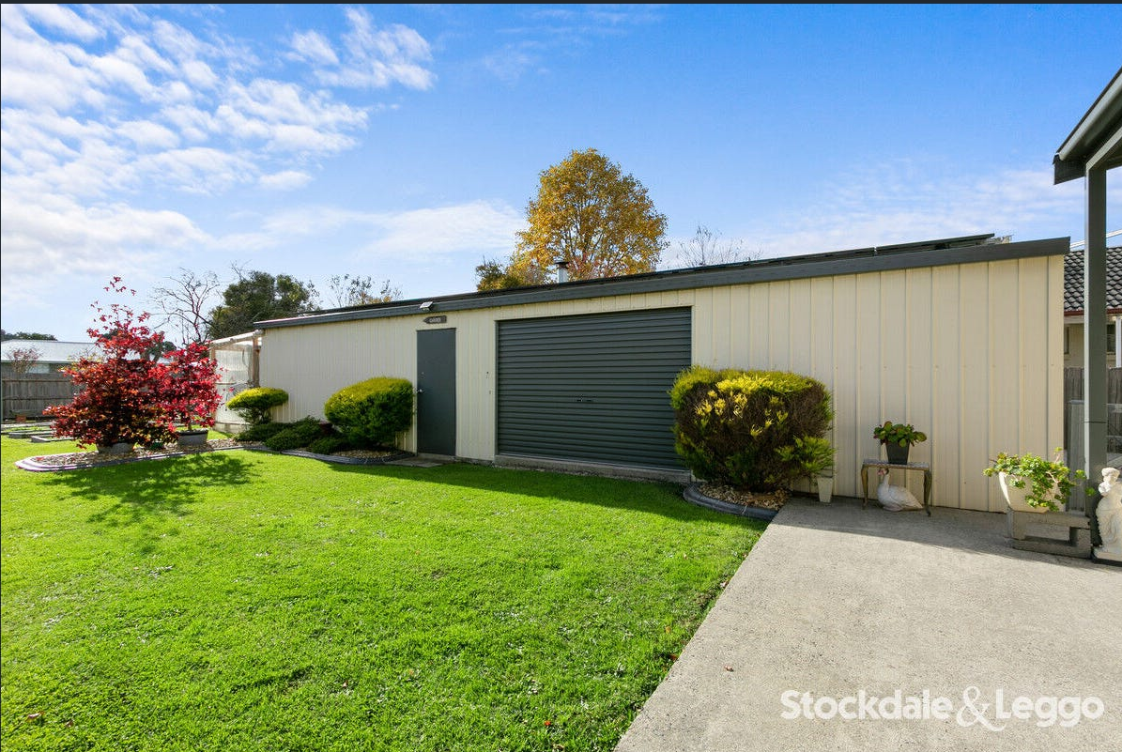
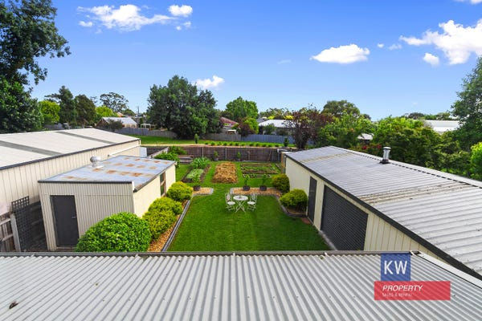
Shed Extension – 5.8m x 6m x 2.9m with 1 auto roller door and a door
