Customer Name: Malcolm Bruhn |  | Phone: 0437937946
Site Address: UNKNOWN FORRESTFIELD 6058 |  | Email: malcolmbruhn@yahoo.com.au

Dear Malcolm,

We are pleased to present our quote for your new Fair Dinkum Builds/Western Sheds steel building.

The features of this quote refer to the supply of materials only unless stated otherwise, based on the information discussed to date.

We’re one of Australia’s biggest and most trusted names in sheds.

All our sheds are made from quality Australian BlueScope® Steel, and we are ShedSafe accredited – giving you the confidence that your shed meets the requirements of the Building Code of Australia (BCA). Your steel building will be manufactured locally in Perth WA.

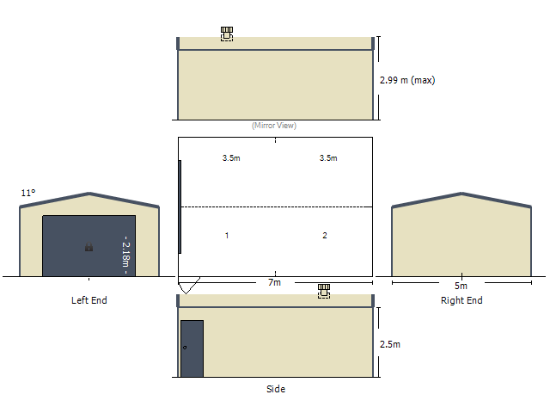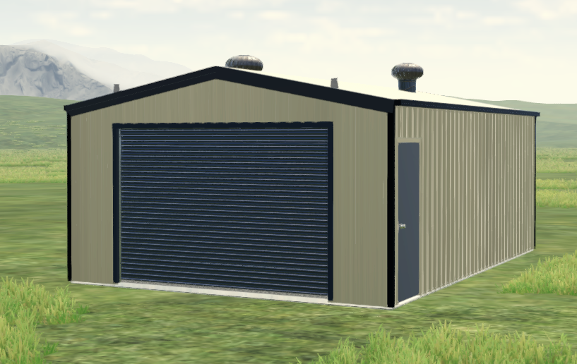

YOUR SITE-SPECIFIC WIND SPEED ASSESSMENT
For your peace of mind, we are ShedSafe accredited and utilise the Australian Steel Institute’s site check software to ensure your shed design is engineered specifically for your site and local conditions. By using this very accurate and sophisticated program, we can determine your site-specific wind speed to provide you the best solution for your project.
BUILDING SUMMARY |  | DESIGN FACTORS
Dimensions:
Span | 5m | Importance Level | 2
Length | 7m | Wind Region | Reg A
Bay Width | 3.5m x 2 bay(s) at 2.5m each | Terrain Category | TCat 2.5
Height to the  Lowest Eave | 2.5m | Topography | 1
Roof Pitch | 11Deg Gable | Shielding Factor | 1
Left Lean-to |  | Internal Pressure  Co-efficient | -0.3, 0
Right Lean-to |  | Side Wind Speed in m/s | 39.15 m/s
Column Fixings | Bolt to Slab

OPTIONAL EXTRAS
Gutters & Downpipes | Easiline Domestic Gutter CB & Downpipes
Roller Doors | 1 x 2.50h X 3.40 CB *Series A # Windlocked
PA Doors | 1 x Deluxe Personal Access Door. 2040 x 820 x 35mm - Pre-Hung - Single Skin - P/C Tube Frame - 180 deg - CB
Whirlybirds | 2 x Roof Ventilators
MATERIAL SPECIFICATION
Walls | Monoclad TCT 0.47, CB | Roof | Corrugated TCT 0.47, CB
Columns | C15015 | Purlins | Z10010
Rafters | C15012 | Side Girts | Z10010
Knee/Apex Brace | C10010 | End Girts | Z10010

PAYMENT SCHEDULE:
All prices include GST
Payment Schedule
Deposit (includes engineering drawings) | $1,000
To order your materials | $4,425
Payment before pickup | $4,425
Total Kit Price: (Ex-Factory Perth) | $9,850
Optional Extras:
Delivery | $ 450
*Concrete | $2,560
*Install | $3,450
TOTAL | $16,310

Total bill cost over $20,000 will require a registered builder or completed as an Owner/Builder.
Please Note: registered builder’s costs are not included.

Total price quoted above is a discounted price and is not available for finance.

*Prices quoted are with owner organising & paid direct to the contractor.
Western Sheds can arrange concrete & install on your behalf but there will be a surcharge added to the * prices.

All council approvals are referred to Complete Approvals and will be quoted individually.

This price covers entirely our offer. Anything that has been discussed or implied that is not covered specifically in this quote has not been allowed for and will not be supplied. If you find something missing that you require, please contact us and we will happily send you a revised quote.

PAYMENT DETAILS:
Bank Details: ANZ
Account Name: Western Sheds
BSB: 016 498
Account Name: 4604 345 12
Your Reference No: 100314

COLOUR SELECTION:
Please fill out and return

Roof ..………………………………………………………………………
Walls ………………………………………………………………………..
Corner Flashing ………………………………………………………………………..
Barge ………………………………………………………………………..
Gutter ………………………………………………………………………..
Downpipes ………………………………………………………………………..
Roller Doors ………………………………………………………………………..
Roller Door Trim ………………………………………………………………………..
PA Door ………………………………………………………………………..
Window ………………………………………………………………………..
Internal Wall ………………………………………………………………………..
TERMS & CONDITIONS
- Our steel supplier has allocated a fixed price based on existing steel stock. This is in limited supply and for this reason the provided quote will be valid for 5 days and may be amended due to price rises, errors and or omissions.
- Payment of deposit does not hold the quoted price. Final price will be dependent on when materials are placed into manufacture with the suppliers.
- No materials will be ordered before manufacture payment or released before pickup payment received.
- Estimated pickup is approximately 6 weeks after order payment received.
- Install price is quoted with power onsite. Please note that if power is not available that additional charges will apply.
- Site works to be completed by owner/client.
- Sheds pad area to be flat level sand with easy access – if concrete pump required this will be at owner’s/client’s expense.
- Area around shed’s pad to be clear, level sand - 1m for sheds between 2.4m to 3.5m high & 3m for machinery access for sheds above 4m in height. There may be additional costs if this is unattainable.
- All footings to be dug by hand, hard digging (i.e., needing an auger, jack hammer etc.) to be at owner’s/ client’s cost.
- Owner/Client is to supply description of site to enable shed company to supply correct engineering drawings.
- Engineering drawings supplied by Western Sheds.
- Amount to generate engineering drawings is non-refundable. Engineering drawings can be amended at any stage with no additional charge excepting specialised designs.
- Claims for missing or damaged materials must be made within 5 days of pickup. No late claims will be accepted.
- All materials will remain the property of Western Sheds until such as the client has paid in full.
- Western Sheds are not responsible for removal of any leftover material from the site unless previously requested. Additional charges may apply.
- All building instructions are made freely available on our website www.westernsheds.com.au Please find link: https://www.westernsheds.com.au/about-us/resources/ With regards to roller door instructions please contact Western Sheds.
- All trades engaged on behalf of owner/client and not employed by Western Sheds.
- Western Sheds will not be responsible for any delays on any deliveries.

I have read the details herein and the terms and conditions of the order and agree to place the order.

Building help: https://www.youtube.com/user/fairdinkumsheds

Name: .............................................. Signature: ............................................. Date: ……………………

Postal Address: ........................................................................................................................
Site Address: ............................................................................................................................
Phone Number: ........................................................................................................................
Email Address: .........................................................................................................................

